**Selenium Assignments**

DATA PROVIDER: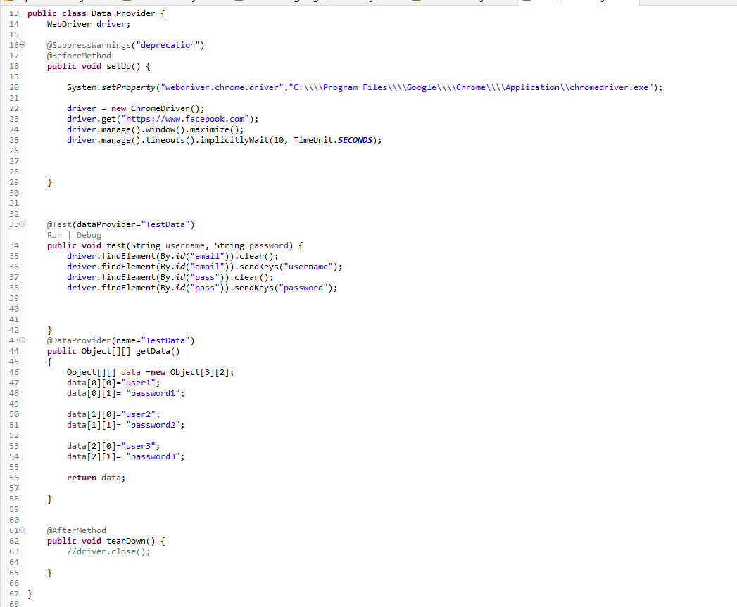

OUTPUT:

